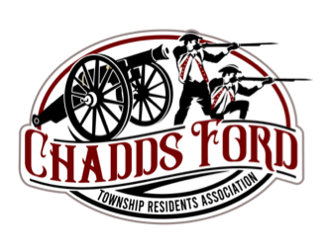The Chadds Ford Township Residents Association 2023 Citizen of the Year Nomination Form
The Chadds Ford Township Residents Association Citizen of the Year Award recognizes accomplished citizens in Chadds Ford Township, Delaware County who have made an impact on Chadds Ford throughout the years by their outstanding character and exceptional deeds.
One resident is identified for the award using criteria established by the Awards Committee of the Residents Association Board of Directors.
Submissions must be received by November 3, 2023. The Board will vote on an Award recipient to be announced on approximately November 8th. The award ceremony will be in early December 2023.

Requirements for Application
● The citizen must reside in Chadds Ford Township, Delaware County.
● Submissions may be made via email or regular post:
info@cftra.org
2023 Citizen of the Year Award
Chadds Ford Township Residents Association P. O. Box 823
Chadds Ford, PA 19317

CITIZEN OF THE YEAR NOMINATION FORM
Page 2 of 2

Citizen Name:
Citizen Address:
Citizen Email:
Citizen Phone:

Submitter Name:
Submitter Address:
Submitter Phone:
Submitter Email:

Please tell us why you think this citizen has accomplished one or more of the following:
1) helped create a strong sense of community within the Township 2) supported its residents through volunteer activities
3) helped retain the Township’s unique historical quality and rural character 4) demonstrated extraordinary leadership in support of the community
How has this person made an impact on Chadds Ford and made our home along the Brandywine a better place to live?
Answers can be submitted electronically in PDF, MS Word, or Google Docs format.

